# Lab 3: CSS

# Prepare your project:

* Download the provided starter code.
* Add the css-reset stylesheet (create an empty CSS file, then use the extension ctrl+alt+r).
* To have a clean html file, externalize your CSS rules in the external file css/styles.css, notice the link tag in the head section:

<link rel=”stylesheet” href=”css/styles.css”>

(Optional):

If you want to modify the html-snippets-ska extension, you can download it (or fork the project) here:

<https://github.com/skanderturki/vscode-html-snippets>

# Style the table:

Open the provided code (home.html). Then, apply the following style to your table:

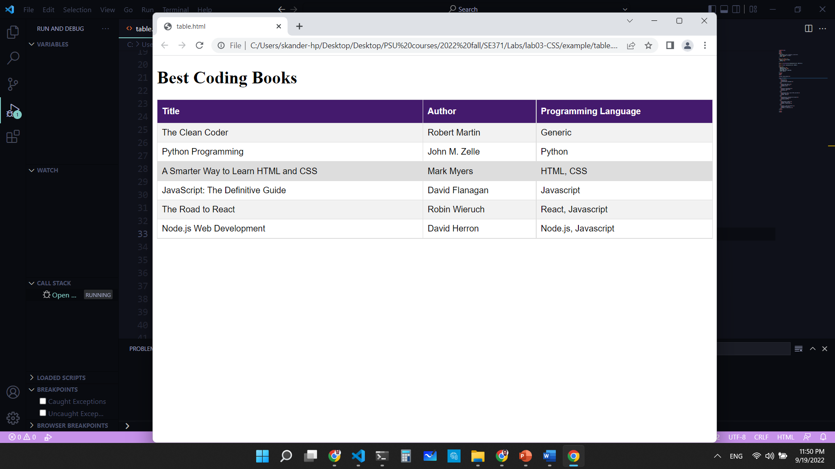

Fig 1. Style to apply to your table.

Steps:

1. For the table, use an ID selector and specify rules for:
   1. Font-family.
   2. The borders should be collapsed (border-collapse property).
   3. Width: must be 100 % of the parent.
2. For the td and th:
   1. Add a solid border of 1 pixel with a color of your choice.
   2. Add a padding of 8 pixels.
3. For the th:
   1. Add top and bottom paddings of 12 pixels.
   2. Align text to the left.
   3. Add a background color of your choice.
   4. Change the font color to create a strong contrast with the background.
4. Finally, for the tr:
   1. Add a css rule to highlight the row below the mouse position.
   2. Change the background color of even rows for better visibility.

# Style the form:

Open the provided form (register.html). Then, apply the rules that are shown in the picture to it:

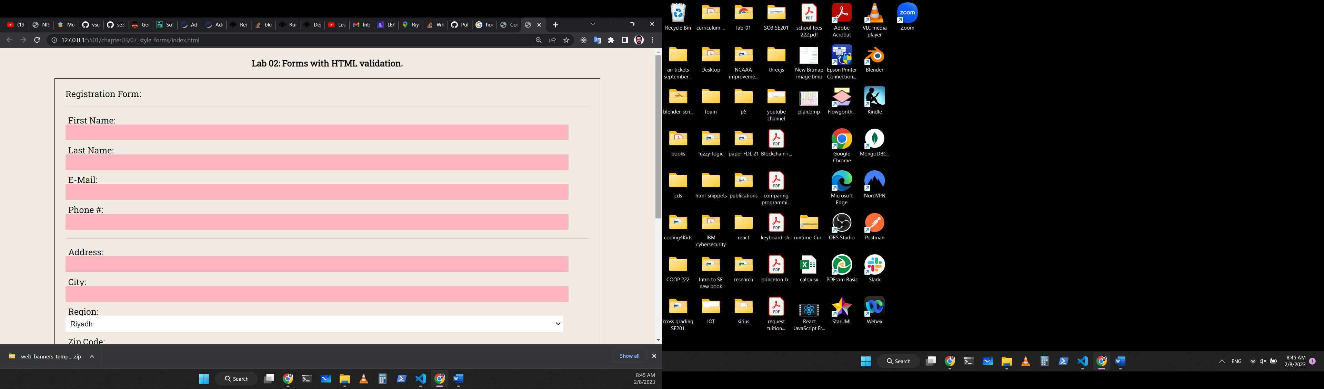

# Additional CSS rules (At Home):

1- Add a font-size property for each of your elements. For example, 16px for all paragraphs inside the main element and 24px for the header elements.

2- Change the color of the header font appropriately.

3- Add a background for paragraphs, example: background: *#eef*;

4- Add a text-transform property to your header to make it uppercase.

5- Add a margin for articles and sections to 20px auto. Add margins for texts of 5px auto.

6- Add padding to your images, nav, texts and aside elements.

